Grade 4 (Week 23: 22/2-26/2)
Unit 9: What’s the fastest animal in the world?
Practice 1
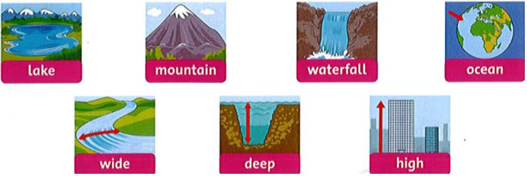
- Write the words:

____________ ___________ ____________ ___________

______________ _____________ _____________
- Read and write T (true) or F (false).

- Nam is the tallest boy. _T_
- Duy is faster than Nam. ____
- Bao is the fastest boy. ____
- Nam is slower than Duy. ____
- Bao is taller than Duy. ____
- Duy is the shortest boy. ____
- Write.
- The U.S.A is bigger (big) than Vietnam.
- Mount Everest is the _________ (high) mountain in the world.
- Cars are ________ (fast) than bikes.
- Grapes are _________ (small) than apples.
- Lake Baikal is the __________ (deep) lake in the world.
- Mice are __________ (slow) than cheetahs.

